Sociology of Immigration
SOC 3206 (Spring 2020)
Tuesdays/Thursdays, 2:15pm-3:30pm, Location: James Hall 2407B

Instructor: Dr. Donna-Lee Granville
Office:3103a James Hall (across from the elevators)

Email: dgranville@brooklyn.cuny.edu
Weekly Drop-In Hours: T/Th 4-5pm & by appointment
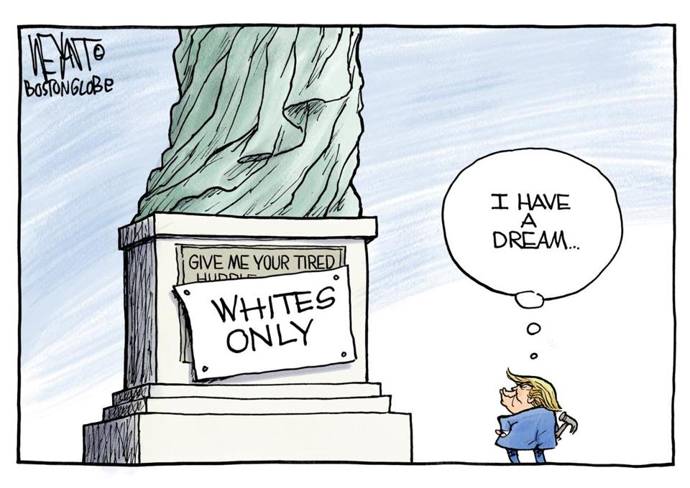

The New Colossus
"Give me your tired, your poor,
Your huddled masses yearning to breathe free,
The wretched refuse of your teeming shore.
Send these, the homeless, tempest-tost to me,
I lift my lamp beside the golden door!"
Emma Lazarus (1883)

Course Description

The New Colossus, written by Emma Lazarus’ and inscribed on the Statue of Liberty, is often used as support for the idea that the United States is a ‘nation of immigrants’. In reality, this poem and the ideology it buttresses masks many ugly truths about immigration. The truth is that we don’t welcome all immigrants with open arms or desire for them to stay permanently. These truths lead to contradictions in U.S. policy on immigration and the material consequences immigrants face as a result. Moreover, as immigration enforcement efforts increase with each new presidential administration, the resulting patterns of deportation and exclusion call into question the intent of policies that claim to protect American citizens at the expense of immigrants of color. This course addresses these complicated dynamics demonstrating how the United States plays dual roles protecting its image as a nation of immigrants while simultaneously determining the boundaries of who belongs often along racial lines.

COURSE OBJECTIVES:
By the end of this course, you will be able to:
- Apply the sociological imagination, (the ability to see how individual biographies are linked to larger social structures and institutions), to an analysis of various immigration issues.
- Understand the core sociological debates, methods, and concepts in immigration studies.
- Demonstrate knowledge of U.S. immigration history including changing laws, flows, groups, and destinations.
- Analyze and discuss race as a central organizing principle of American immigration.

COURSE MATERIALS:
- There is no required text for this course. All readings will be available on our course site starting Week 2 (Feb 4-6th).
  - For course announcements, and any readings for Week 1, please see Blackboard.
Grading & Assignments
Your final grade will be based on the following assignments:
Assignment | Weight (%) | Points | Due Date
Attendance/Participation | 25% | 100 | Every Class
In-Class Quizzes (10 @ 10 pts each) | 25% | 100 | Weekly
Op-Ed Project | 25% | 100 | 4/21-4/23; 5/7
Final Exam | 25% | 100 | 5/21
Total |  | 400

- ATTENDANCE/PARTICIPATION–Attendance is about more than being physically present in the classroom—it is also about actively participating in class discussions. This includes the quality of your participation i.e. having read for class, contributing to the discussion, being disruptive, or excessive use of electronics. From time to time you will also be completing in class activities like responding to a video or an essay prompt that will be collected to assess your participation. This portion of your grade is worth 100 pts.

- IN-CLASS QUIZZES–Each week you will take an in-class essay quiz on the assigned reading(s) for that date. Quizzes can take place on Tuesday or Thursday so you should be prepared at each class session. Each quiz is worth 10 pts and a total of 12 quizzes administered with the highest 10 grades counting towards your final grade. This portion of your grade is worth 100pts.

- FINAL EXAM– At the completion of the class, you will take a final exam demonstrating your knowledge of key concepts and your ability to apply them to real world scenarios. This will be a cumulative exam based on course lectures, readings, in class activities. More details on this assignment will be provided on BB. This portion of your grade is worth 100pts.

- OP-ED PROJECT– Our ongoing project this semester is to take the knowledge we’ve learned and share it. You will write and submit an op-ed on an immigration issue of your choice. This project is broken down into five smaller tasks that will be due in Weeks 3, 5, 7, 13, and 15. This portion of your grade is worth 100 pts.
GRADING SCALE
360-400 | =A+, A, A-
320-359 | = B+, B, B-
280-319 | = C+, C, C-
240-279 | = D+, D, D-
Below 240 | = F

Note: As in all courses, an “A” represents outstanding/exceptional work; a “B” represents good to very good work; a “C” represents adequate work; a “D” represents a borderline effort, and an “F” represents a failing grade.
GRADING GUIDELINES

GRADING INQUIRIES- All assignments will be graded and returned as quickly as possible within a two-week timeline. To further ensure that they are graded and returned in a timely manner, students will have different due dates based on their last name. I will not discuss grades immediately before, during or after class time. Instead we will follow the “24/7 rule” regarding any questions about your grade. That means that I will not respond to any grade questions until at least 24 hours after graded assignments are returned. All grade queries must be submitted in writing within 7 calendar days after the assignment has been returned. Your written statement should include a specific and thought-out rationale for why you feel your answer is correct or why the paper deserves a higher grade. Simply writing, "I think I deserve a better grade" is not a rationale. Once I have received your query, we can schedule a meeting to talk in person.
COURSE POLICIES
OFFICE HOURS AND CONTACT INFORMATION-A successful student is one who is proactive about their education. If at any point you have questions or struggle with course concepts feel free to set up an appointment. You may also reach me by email. I generally respond within 24-28 hrs to emails. When sending emails please use your last name and SOC 3206 in the subject heading (i.e. Granville-SOC 3206) and be sure to adhere to professional writing guidelines. While I am happy to answer questions, if they can be found be on the syllabus, I will simply respond ‘check your syllabus’.

EXCUSED ABSENCES- Excused absences include the following: college-sponsored activities (please notify me at least 3 days in advance), an unforeseen family emergency, and illness serious enough to seek the attention of a health-care professional. You must also provide documentation (i.e. an obituary or doctor's note). Family trips, traffic and routine medical appointments do not qualify as an excused absence. Whether or not your absence is excused, if you miss a class, it is your responsibility to ask another student in the class for notes and/or an explanation of what was covered that day.

ACADEMIC INTEGRITY- The faculty and administration of Brooklyn College support an environment free from cheating and plagiarism. Each student is responsible for being aware of what constitutes cheating and plagiarism and for avoiding both. The complete text of the CUNY Academic Integrity Policy and the Brooklyn College procedure for implementing that policy can be found at this site: http://www.brooklyn.cuny.edu/bc/policies.

CLASSROOM ETIQUETTE- All cell phones should be turned off or placed on silent during class. Activities that may be distractions to the class such as cell phone usage, “tweeting/status updating,” eating large meals, and the like are prohibited during class time. Laptops may be used in class however, they must be used for class purposes such as taking notes, not checking your email or Facebook page. If found in violation of this policy, you will warned and then asked to leave.

SYLLABUS CHANGES- The syllabus is subject to change over the duration of this course; however, you will always be notified of changes via BB and class announcements. It is your responsibility to keep abreast of course changes and requirements.

LECTURE SLIDES- I will post lecture slides or notes for class lectures on Blackboard after class. Having these slides will hopefully help you to pay more attention in class but they do not contain all the material you need to know. Additionally, not attending class but reviewing slides or notes is a poor substitute for attending lecture.

CLASS CANCELLATIONS- If class is canceled, you will be notified as early as possible via your Brooklyn College email account and Blackboard. You can also sign up for text alerts via BC Webcentral.

RESOURCES FOR THRIVING & SURVIVING

FACING CHALLENGES? -Sometimes in a semester circumstances arise that may negatively impact your grade. If at any point you experience such a challenges or issue—don’t wait! Be proactive and make an appointment to see me as soon as possible.

DISABILITY SERVICES- To receive disability-related academic accommodations students must first be registered with the Center for Student Disability Services (CSDS). Students who have a documented disability or suspect they may have a disability are invited to set up an appointment with the Director of the Center for Student Disability Services, Ms. Valerie Stewart-Lovell at 718-951-5538.

IMMIGRATION RESOURCES- As an educator, I support the rights of undocumented students to an education. If you have any concerns in that regard, or about other immigration issues feel free to discuss them with me, and I will respect your wishes concerning confidentiality. For resources and support, please visit Brooklyn College’s Immigrant Student Support Office, 117 Roosevelt Hall, website: Immigrant Student Success Office or visit: https://libguides.brooklyn.cuny.edu/DACA

HOW TO PREPARE FOR CLASS
For each class date listed below, there is a topic, assigned reading(s), and any assignment due .
- To prepare for class, read and take notes on the assigned reading listed for the date, before we meet for class.
  - Be sure to note the topic of the day and consider how the assigned readings help you to better think about or understand our topical focus. Turn the title of the article into a question and use your notes to produce the answer.
- Once you arrive to class, review your notes on the reading(s) so you are prepared for the class discussion and any possible quizzes.
- So for class on 1/30, read Johnson’s chapter on Population Ecology before class and be sure to take good notes. Jot down any questions you may have and highlight any areas in the reading you found significant.

Week | Date | Topic | Readings | Assignment Due

Unit 1. Thinking Critically About U.S. Immigration
Wk. 1 | 1/28 | Course Introduction | - No Readings
 | 1/30 | Understanding Human Migration | - Johnson-Population Ecology | On BB
Wk. 2 | 2/4 | Understanding Human Migration II | - Hightower- Immigrants Come Here Because Globalization Took Their Jobs Back There  - Turrentine- Climate Change Is Already Driving Mass Migration
 | 2/6 | Understanding Human Migration II | - Massey- Why Does Immigration Occur?
Wk. 3 | 2/11-2/13 | Immigration Issues in a Nation of Immigrants | - The U.S. Immigration System May Have Reached a Breaking Point  - Frum-How Much Immigration Is Too Much?
 |  |  |  | Op-Ed #1-2/14
Wk. 4 | 2/18-2/20 | Race and ‘American’ Identity | - Spickard- Immigration, Race, Ethnicity & Colonialism  (2/18—pgs 1-18; stop before Race v. Ethnicity)  (2/20—pgs 18-28; start with Race v. Ethnicity )
Wk. 5 | 2/25 | Critiquing Assimilation | - Bashi-Treitler- The Irish, Chinese, Italians, and Jews: Successful Ethnic Projects  - Gordon-Assimilation in American Life | Op-Ed #2-2/28
 | 2/27 | Critiquing Assimilation | - Molina- The Myth of the Unassimilable Mexican  - Bashi Treitler- The Native Americans, Mexicans, and Afro-Caribbean’s

Unit 2. The Legal Landscape: Law, Policy and Social Control
Wk. 6 | 3/3 | Legal Transformations | - Vargas-My Life as an Undocumented Immigrant  - Ngai-How Grandma Got Legal
 | 3/5 |  | - Ioffe-This Is What It's Like to Come to the United States as a Refugee  - Bayoumi-How Being Thrown in Jail After 9/11 Changed One Arab Girl's View of America
Wk. 7 | 3/10-3/12 | Immigration Law: Past & Present | - Okrent-A Century Ago, America Built Another Kind of Wall  - The 1965 Immigration and Nationality Act | Op-Ed #3-3/13
Wk. 8 | 3/17-3/19 | The Criminalization of Immigrants | - Macías-Rojas,- A New Enforcement Terrain  - Black Undocumented Immigrants & Deportation
Wk. 9 | 3/24-3/26 | Naturalization & Citizenship | - Aptekar-Making Sense of Naturalization
- Felix-Dreams of Citizenship, Naturalization Nightmare
- Aptekar- Celebrating Immigrants
Wk.10 | 3/31 -4/2 | Gender & Sexuality | - U.S. Immigration Law Treats Women And Men Differently  - Longo-Mothers and Moneymakers
Wk. 11- 12 | 4/7-4/16 | SPRING BREAK!!!!
Wk. 13 | 4/21-4/23 | OP-ED PROJECT | In-Class Peer Review | Op-Ed Draft-4/21
 |  |  | In-Class Editing/Writing Session

Unit 3. A More Perfect Union: Immigrant Integration
Wk. 14 | 4/28-4/30 | The U.S. Racial Hierarchy & the Racialization of Immigrants | - Ocampo- Are second-generation Filipinos ‘becoming’ Asian American or Latino  - Zopf-A Different Kind of Brown
Wk. 15 | 5/5 | Contexts of Reception | - Hazelton, PA  - Immigration in New York City | Op-Ed Final-5/8
 | 5/7 | Immigration Reform | - Brown & Jones- Immigrants’ Rights Are Civil Rights  - Caravan, Invasion, Exodus
Wk. 16 | 5/12-5/14 | In Class Exam Review

Final Exam- 5/21

